BRON 1
WTTC, 2015, Travel & Tourism, Economic Impact 2015, Albania

BRON 2
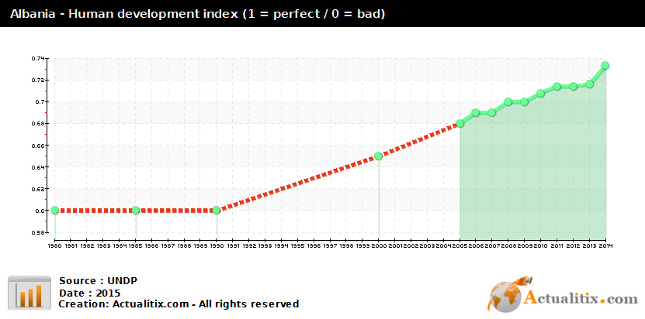
De index van de menselijke ontwikkeling (ontwikkelingsindex), VN-index (welzijnsindex) of Human Development Index (HDI) van de Verenigde Naties meet voornamelijk armoede, analfabetisme, onderwijs en levensverwachting in een bepaald land of gebied.
De index meet de gemiddelde prestaties van een land, opgedeeld in drie categorieën:
- Volksgezondheid, aan de hand van de gemiddelde levensverwachting bij de geboorte.
- Kennis, aan de hand van het analfabetisme en het deel van de bevolking dat primaire, secundaire en tertiaire educatie doorloopt.
- Levensstandaard, aan de hand van het bruto nationaal product per hoofd van de bevolking, in koopkrachtpariteit in dollars.

Wikipedia, 2017, Index van de menselijke ontwikkeling, https://nl.wikipedia.org/wiki/Index_van_de_menselijke_ontwikkeling

BRON 3
WTTC, 2015, Travel & Tourism, Economic Impact 2015, Albania

BRON 4

Promotions Boost Albanian Tourism as Visitors Increase
State-financed promotions, combined with those of private operators and apartment owners using online booking platforms, is believed to be a reason for the increasing number of foreign tourists in Albania.

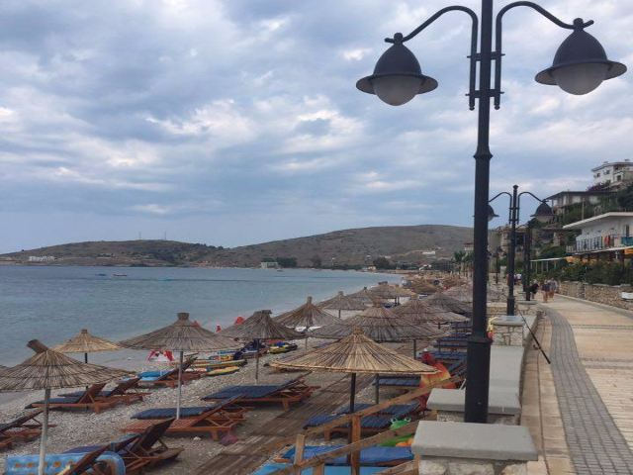
The Qeparo tourist village in the south of Albania. Photo: BIRN

Albanian tourism experts believe that the growing numbers of holidaymakers choosing to spend their summer vacations in the country is mainly a result of promotions.
Matilda Naco, director of the Albanian Tourism Association, told BIRN that this summer was one of the best in terms of numbers of foreign tourists. "I believe the number one reason why Albania has been favoured is mainly because of promotion. State institutions and also private operators have raised their budgets when it comes to country presentations at world tourism exhibitions. Also, the level of presentation has become more professional and efficient," Naco said.
"It is a fact that Albania is still one of the least discovered countries in Europe, so curiosity also plays a role," she added.
The minister of Economy and Tourism, Milva Ekonomi published figures on suggesting that 24 per cent more foreign tourists chose Albania as a destination this year compared to 2015.
"The numbers speak for themselves," the minister wrote on Twitter.
The data showed the numbers of tourists crossing the country's land and sea borders from June 1 to August 15
Naco said that local entrepreneurs have done a good job this year promoting their apartments via increasingly popular online booking platforms like Airbnb.
"In 2013 the number of apartments listed for rent at Airbnb was only 35, now it has soared to thousands while the majority of properties in the coastal towns and cities are registered on the platform," she said.
Brunilda Licaj, an expert in tourism and lecturer at the Aleksander Moisiu University in Durres, also told BIRN that the added promotion in Albania has brought positive growth in the number of foreign tourists this year.
Licaj also believes that the difficult situation in Turkey has contributed to growing numbers of tourists visiting the Balkans.
...
The lower price of accommodation compared with other countries in the region is also considered by experts to be a factor in the growing number of tourists in Albania this year.
According to the booking.com platform, the price for a night in a four-star hotels in Vlora or Saranda during August starts from 50 euros and rarely exceeds 150, while in Budva in Montenegro, the price for this category start from 75 euros and goes up to 200.
Prices go even higher in Croatian coastal towns of Dubrovnik and Split, starting from 130 euros and going up to 220.

Fatjona Mejdini, BIRN, Balkan Insights 2016, http://www.balkaninsight.com/en/article/experts-consider-promotion-main-factor-of-tourism-growing-in-albania-08-22-2016

BRON 5
A large number of tourists arrived on Albania's shores this year. Unexplored beaches and good food are the main attractions.
In recent years, an increasing number of foreign tourists are visiting Albania. The country has become a regional tourist destination after shaking off its prolonged communist-era isolation, during which it fell into obscurity.
Among the populated beaches of Durres and Vlora, Albania offers unexplored stretches on the north and south coasts of the Adriatic and Ionian seas, which are attracting more interest among foreign tourists.
…
"Increasing the accommodation capacity and raising the quality of service remain the main challenges for Albanian tourism," said Pango.
Albanian entrepreneurs are aware that their infrastructure remains one of their biggest problems. "The secondary roads to the beaches remain very problematic, even though the cost to build or rehabilitate them is irrelevant," said Sadik Malaj, the head of the Albanian Union of Tour Operators.
Nonetheless, the government is promoting the industry and announced plans for upcoming resorts. Entrepreneurs from Dubai and Qatar expressed interest in financing a substantial development on the Bay of Lalzi, said Pango.
In addition, the French chain Club Med plans to build about 350 luxury villas overlooking the Bay of Kakome, thus investing 75m euros.
One of the strongest points of the Albanian tourist industry is the local cuisine, a tempting blend of Greek and Turkish influences.
According to the Bank of Albania, the tourism industry attracted in 170m euros in revenue in 2007, making it a major engine of national economic growth.
Albanian real estate is also now a new chapter for Albania as more and more foreigners do realise the Albanian property market and its oportunities for growth and rental return or purely as a holiday use.

Albania Properties, 2016, http://www.albania-properties.co.uk/news/albanian-tourism-rise#.WNl3IvnyhPY

BRON 6
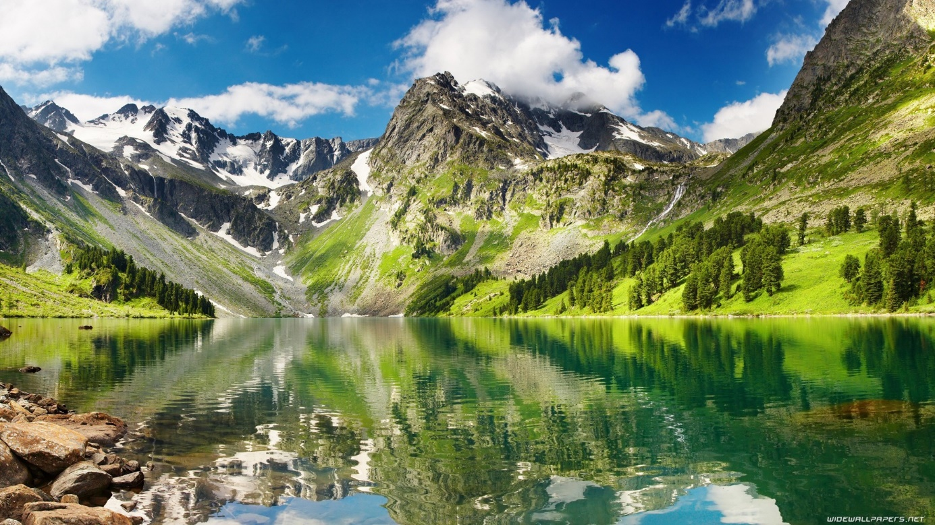(https://designurart.wordpress.com/2015/03/13/natures-forgotten-beauty-albania/)
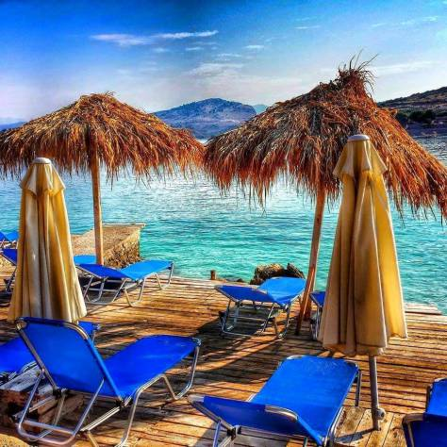(https://invest-in-albania.org/20-places-that-will-change-your-mind-about-albania/)

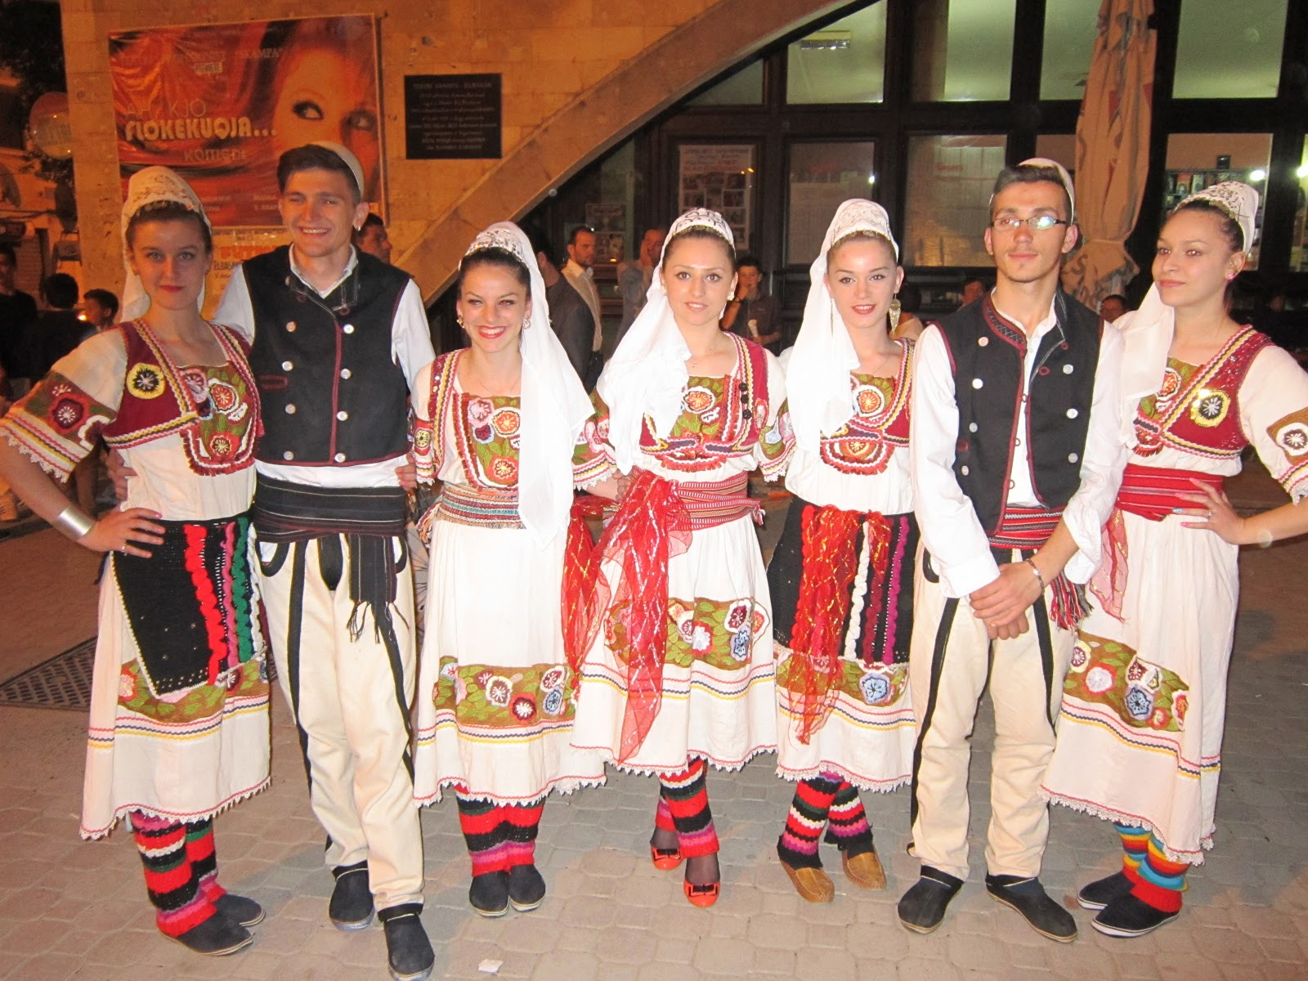(http://www.keepcalmandtravel.com/albania-travel-tour-like-albanian-people/)
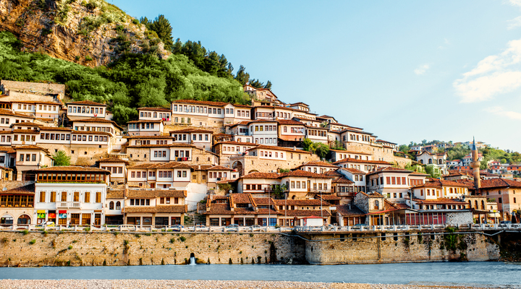
(https://www.reisgraag.nl/vakantie-albanie/bezienswaardigheden/)

BRON 7
Albania may be a little country but there is a lot to see and do in this exciting up-and-coming location. Bordering Macedonia, Greece, Kosovo and Montenegro, Albania’s long coastline is one of the most ruggedly beautiful in the world.
While Albania is slowly becoming more popular with tourists it remains extremely undiscovered, as well as almost completely unspoiled. Albania boasts some of the best examples of Ottoman architecture in the world, along with supremely clear Mediterranean air and stunningly fabulous beaches.
And, perhaps best of all, travelling to Albania remains an extremely affordable trip, even compared to much of the rest of this part of Europe. Let’s have a look the best places to visit in Albania!

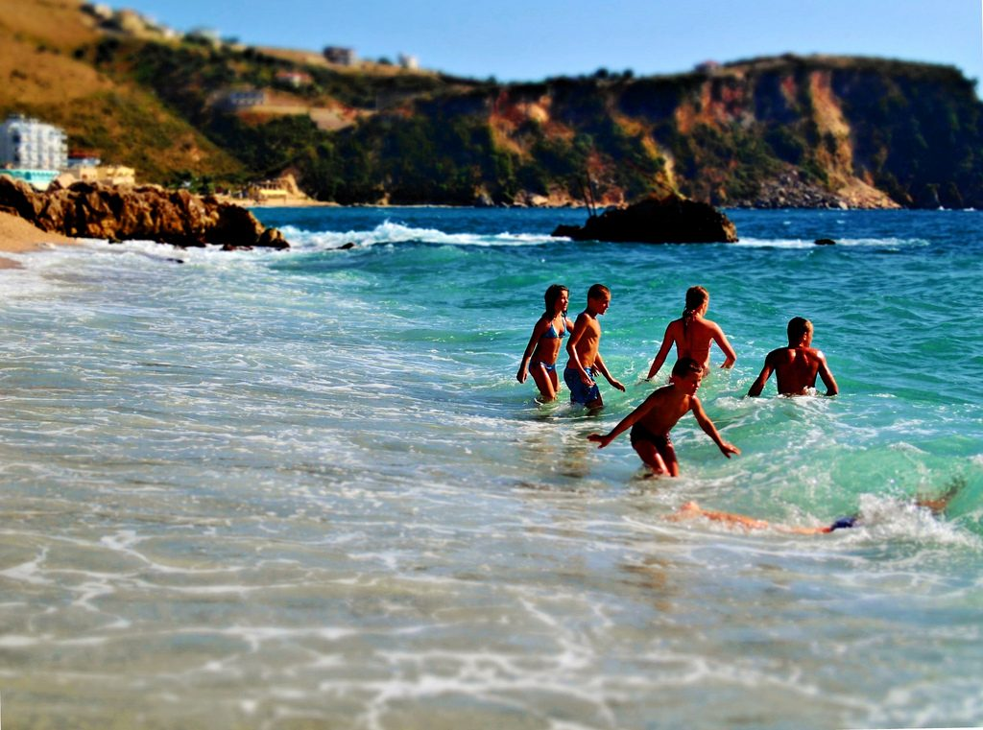
The Crazy Tourist, 2017, https://www.thecrazytourist.com/15-best-places-to-visit-in-albania/

BRON 8

Klimaatinfo, http://www.klimaatinfo.nl/albanie/
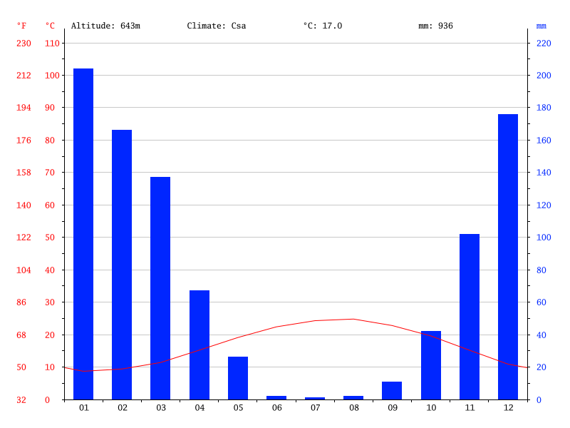Climate-Data.org, 2017, https://de.climate-data.org/location/420126/

